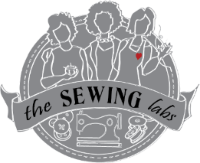
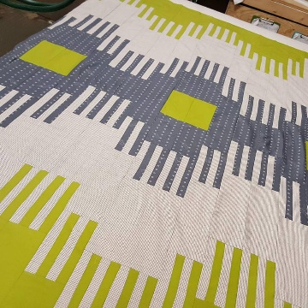
Gratitude & Grace Quilting Retreat
July 28, 29, 30, 2017
@ The Sewing Labs

Be a Member of our Gratitude & Grace Quilt group.
We are very excited about this fundraiser; a quilting retreat.
Join our kindred spirit group of sharing/learning the art of quilting.
What to Expect:
Friday Night – Doors open & check in starting @ 5 pm. Gathering starts @ 6 pm. We will gather to get to know each other. Participate in Sew-N-Tell, and have a round table talk. Quilt Pattern & fabrics will be distributed. Snacks served.
Saturday – Doors open @ 7 am Continental Breakfast available @ 7:30– 8am Sewing Room rules & overview explained. Sewing Station set up & overview of quilt design explained. Cutting instructions and off we go!!!! Lunch break @ 12 noon – serving thru 1pm. Sewing throughout the day, Dinner served @ 5- 6 pm. Trunk show of a selected designer will be following dinner @ approximately 7 pm for those who want to participate. Sewing room open until 10 pm.
** Special YOGA session taught to stretch you out from sewing – by Diane Little – Yogini **
Sunday – Door open @ 7 am Continental Breakfast available from 7:30 - 8am. Sewing & sewing throughout the day. Quick Tips lesson @ 11 am. Roundtable focusing on Gratitude. Lunch served 12-1. Finishing up & preparing to leave by 2 pm.
Snacks – We encourage you to bring a snack to share with the group – these snacks will be available at all times in the Community Center Kitchen area. NO ALCOHOLIC BEVERAGES ALLOWED
**Children are not allowed at the retreat – Age limit – 13 & beyond. Young sewers must have prior sewing experience & be accompanied with an adult.
What to Bring
- Bring your own sewing machine & accessories (extra needles, ¼” foot or regular foot, etc.)
- Basic supplies – cream thread, pins & pin cushion
- Power strip or extension cord
- Cutting board, cutter, ruler, scissors
- Ironing board & iron – Optional; we will have some available
- Casual, comfy attire
- Personal sewing lamp - optional
What we Supply
- Pattern & Fabric* for Full/Queen size bed – larger sizes available by request – suggested donation as follows: King = $35
(*fabric will vary from photo)
- 5 meals – Saturday = B,L,D, Sunday = B,L Friday night snacks
- Sewing Room access from 7 am – 10 pm
- Table for cutting
- Irons & ironing boards
- Sewing tables & electrical outlets
- A kitchen (microwave, refrigerator)coffee pot
- Dishes, mugs, flatware

The Quilting Retreat for July 2017 will be located at The Sewing Labs @ 803 E 27th, intersection of 27th & Charlotte. Parking lots is located on the east side of the building, Enter thru glass doors

REGISTER NOW! For this 3 day & 2 night extravaganza of quilting. Single Registration = $200.00 suggested donation, Double Registration = $350.00 suggested donation
Name(s): ______________________________________________________________________________________________________
Address: _______________________________________________________________________________________________
Email Address: _________________________________________ phone #: _________________________________________
Special instructions: (dietary needs, mobility needs, if child – age and adult partner, etc.) ______________________________________________________________________________________________________
Payment Information:
Payment Schedule – Deposit $50 donation holds your spot (if received before June 31st you will have a $25 discount off balance), Payments suggested: Second payment $100 due by July 15th, final payment $50 due at retreat. Or you can pay in full anytime.
Payment Type – please do not send cash thru the mail - PayPal available on line@ http;//thesewinglabs.community
Check # _______________________ Date Written _____________________
Credit/Debit Card: you can fill this in below or call us for immediate processing of donation
Name on Card: ___________________________________________ Phone # _______________________________________
Address on Card if different than above; ___________________________________________________________________________
Card Type: M, V, AmEx, D Card # _________________________________ Exp. Date _______________ Security Code ___________
Signature of Authorization for transaction; _________________________________________________________________________
REFUND POLICY - Your initial deposit of $50 is a NON-REFUNDABLE donation. If you register and are unable to attend, this portion of your fee will go to support the program. If you are unable to attend, any remaining portion of your payments will be refunded to you or you may transfer this registration to someone else or to a future event (future event must be used within 12 months)
____________________________________________________________________________________________________________________________________________________________________________________________________________
This retreat is a fundraiser. A portion of your fees go to support the program. You may also consider donating your quilt to be auctioned, donated, etc. and funds raised to support the “The Sewing Labs” programs. These programs will provide jobs training or skills for women in marginalized communities in sewing-related industries.
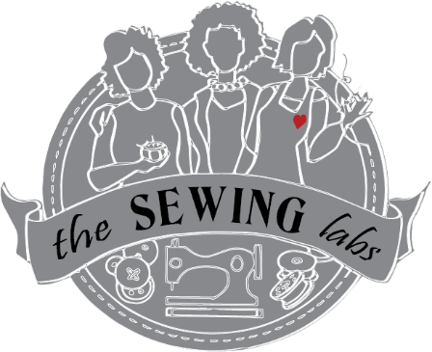
The Cloth Continues…@ http://thesewinglabs.community & www.facebook.com/TheSewingLabs/

for additional questions or information please contact:
CONTACT INFO
Linnca Stevens – Program Manager
The Sewing Labs
803 E 27th Street
KCMO 64108
thesewinglabs@gmail.com
816-286-3097

